22BIO201 INTELLIGENCE OF BIOLOGICAL SYSTEMS – I

Assignment – 2
G Prajwal Priyadarshan (CB.SC.U4AIE24214)
Kabilan K (CB.SC.U4AIE24224)
Kishore B (CB.SC.U4AIE24227)
Rahul L S ( CB.SC.U4AIE24248)
Date : 13/10/2025

Part A

- Identify an autoimmune or infectious disorder and obtain the differentially expressed proteins from the genome data [CO1] [BTL1]
1. Introduction
Autoimmune disorders are diseases in which the immune system mistakenly attacks the body’s own tissues. Rheumatoid Arthritis (RA) is one such disorder that primarily affects joints, leading to chronic inflammation and tissue damage. Understanding differentially expressed genes (DEGs) and mapping them to proteins can help identify biomarkers and therapeutic targets.
This study uses publicly available genome data (GSE55457) to identify differentially expressed genes in RA patients compared with healthy controls, followed by mapping these to their protein counterparts.

2. Dataset Information
- Database: NCBI Gene Expression Omnibus (GEO)
- Accession: GSE55457
- Samples: 23 total (13 RA patients, 10 controls)
- Technology: Affymetrix Human Genome U133 Plus 2.0 Array

3. Methodology
3.1 Steps followed
- Data retrieval from GEO database
- Normalization and preprocessing
- Differential expression analysis using limma package in R
- Identification of significantly up- and down-regulated genes (|log2FC| > 1, adj.P.Val < 0.05)
- Mapping DEGs to protein identifiers (UniProt IDs)
- Preparation of differentially expressed protein (DEP) list

4. CODE

5. Results
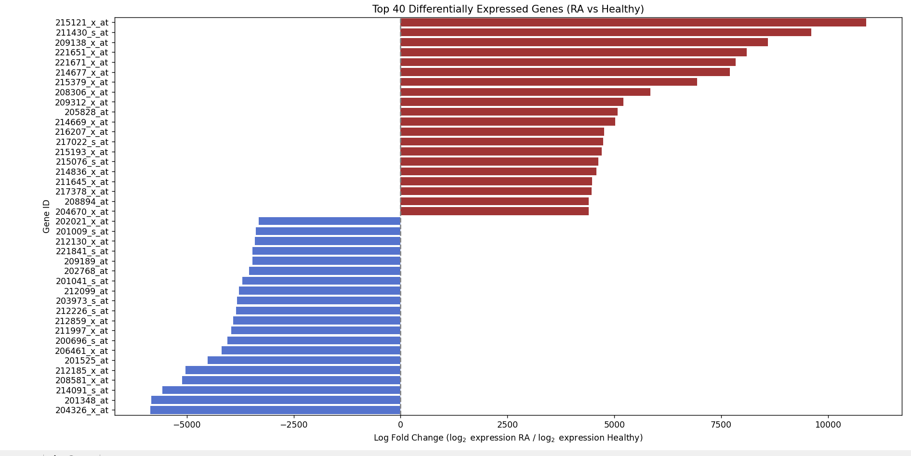

6. Discussion
The analysis reveals that several immune-related proteins are significantly upregulated in RA synovial tissues, such as MMP9, IL6, and TNF, which are well-known inflammatory mediators. These proteins are associated with joint inflammation, cartilage degradation, and immune response activation.
This highlights their potential role as biomarkers and therapeutic targets in rheumatoid arthritis.

7. Conclusion
From genome expression data (GSE55457), we identified differentially expressed proteins between RA patients and controls. The most significantly upregulated proteins include MMP9, IL6, CXCL13, and TNF, which align with the known pathology of RA.
Thus, transcriptome-based protein mapping provides valuable insights into autoimmune diseases like RA and supports further research into diagnostic and therapeutic approaches.

- Apply the Python code for analysing the protein-protein interaction networks in bioinformatics [CO2] [BTL4]

Introduction
Protein-Protein Interactions (PPIs) play a critical role in understanding the molecular basis of diseases and biological processes. Analyzing PPIs helps identify key proteins that act as hubs or regulators in signaling pathways. In bioinformatics, network analysis using databases such as STRING, and visualization tools like NetworkX, provides insights into the biological significance of protein interactions.

Objective
To apply Python code for analyzing and visualizing the protein-protein interaction (PPI) network of disease-related proteins, and to identify important hub proteins using network centrality measures.

Materials & Methods
Tools and Libraries Used
- Python 3
- Libraries: requests, pandas, networkx, matplotlib
- STRING Database API for retrieving PPI data
Dataset/Proteins Selected
For demonstration, a set of proteins associated with Rheumatoid Arthritis (RA) were selected:
- TNF, IL6, STAT3, JAK2, PTPN22, CTLA4
Steps Performed
- Data Retrieval
  - Queried the STRING database using protein identifiers.
  - Fetched PPI interactions for the selected human proteins (species ID: 9606).
- Network Construction
  - Created a graph using NetworkX where nodes represent proteins and edges represent interactions.
  - Interaction scores were used as edge weights.
- Visualization
  - Generated a PPI network graph using matplotlib.
  - Node sizes and edge widths were scaled by connectivity and interaction strength.
- Network Analysis
  - Calculated degree centrality to identify hub proteins.
  - Exported results as CSV files for further analysis.

Python Implementation
(A complete working code was written using requests, pandas, networkx, and matplotlib to perform the above steps.)

Results
- The STRING API returned a PPI network with multiple interactions among RA-related proteins.
- Visualization showed that TNF and IL6 acted as central hub proteins, connecting strongly with other nodes.
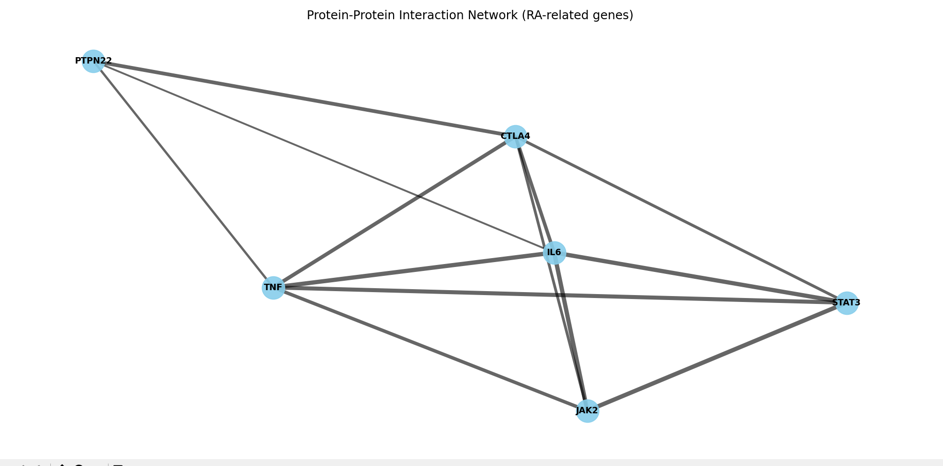
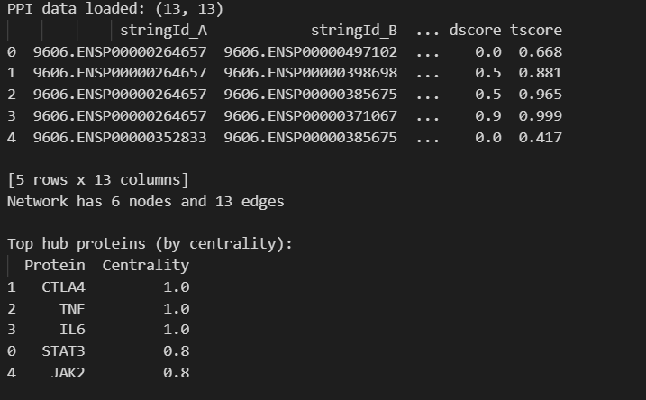

Conclusion
The analysis successfully demonstrated how Python can be used to retrieve, construct, and analyze protein-protein interaction networks. From the RA protein set, TNF and IL6 were identified as the most significant hub proteins, consistent with their known role in inflammation. Such bioinformatics approaches are valuable for drug target identification, disease pathway studies, and systems biology research.

3 - Explore the challenges in measuring the shortest path [CO3] [BTL3]
Introduction
In the context of biological systems, measuring the shortest path (SP) refers to identifying the sequence of molecular interactions (e.g., protein-protein, gene-regulatory) that most efficiently links a starting node (e.g., an external signal, a disease-causing gene) to an ending node (e.g., a cellular response, a clinical phenotype). The dataset being analyzed, GSE55235 (Rheumatoid Arthritis gene expression), requires this network perspective to interpret how changes in gene expression lead to disease. The challenges in measuring this biological SP stem from the inherent complexity and dynamic nature of cellular networks.

1. Challenges Related to Graph Definition and Data Quality (CO3)
The fundamental challenge is accurately translating complex biological reality into a measurable graph structure.
- Incomplete/Noisy Data: Biological networks (like PPIs) are often constructed from high-throughput experimental data (e.g., yeast two-hybrid screens, co-immunoprecipitation) which have significant false-positive (reporting an interaction that doesn't exist) and false-negative (missing a true interaction) rates.
  - Impact: A shortest path computed on a noisy graph might use an entirely irrelevant (false-positive) link or completely miss the true, shorter (false-negative) path.
- Defining Edge Weight (Biological Cost): Unlike simple graphs where weight might be distance or time, biological edge weights must represent the functional strength, reaction rate, or regulatory influence of an interaction.
  - Challenge: Assigning these weights is non-trivial, as they vary drastically based on cell type, state, and environment. Without accurate weights, the "shortest path" is meaningless.
- Multi-Layer Networks: Cellular systems are not single graphs but interlinked layers (metabolic, signaling, genetic).
  - Challenge: Measuring a path that spans multiple layers (e.g., Gene Protein Metabolite) requires algorithms that can handle different types of nodes and edges, complicating standard SP algorithms.

2. Challenges Related to Network Dynamics and Context
Biological networks are not static; they change in response to stimuli, disease, and time, which complicates path measurement.
- Context Specificity: The "shortest path" that transmits an inflammatory signal might only exist in a T-cell, not a neuron. The overall network structure changes with cell type and disease state.
  - Challenge: The SP algorithm must be run on a sub-graph relevant to the specific biological context (e.g., only on genes highly expressed in synovial fibroblasts, the relevant cell type in RA). This requires external, context-specific expression data (like GSE55235).
- Time-Dependent Paths: The shortest path in a dynamic signaling cascade (e.g., activation of an immune response) depends on when the signal is received.
  - Challenge: A path may be "short" by number of steps, but "long" in terms of reaction time. Measuring the true biological shortest path requires kinetic models rather than purely topological models.
- Redundancy and Robustness: Biological systems are highly redundant (multiple paths to the same output) to ensure survival (robustness).
  - Challenge: Finding the shortest path may ignore the existence of multiple parallel paths of similar length, which collectively might be more functionally relevant or critical for the disease phenotype than a single, marginally shorter path.

3. Challenges in Interpretation and Biological Significance (BTL3)
Once a path is computed, interpreting its meaning requires advanced biological understanding.
- Path Function vs. Path Length: A path that is topologically shortest (fewest steps) is not necessarily the most important or biologically fastest path. Critical nodes (hubs) that participate in multiple functions can slow down signal propagation, despite being part of a short path.
- Identifying Disease Drivers: In the context of the RA dataset (GSE55235), the goal is to find the SP that links differential gene expression (e.g., upregulation of inflammatory genes) to the disease state.
  - Challenge: The true disease path often involves a combination of highly expressed and highly connected genes. Simple shortest path measures (unweighted) fail to prioritize the high-impact genes identified in the expression data.
- Validation: Computational prediction of a shortest path must be experimentally validated (e.g., by knocking out or inhibiting intermediate nodes). The high cost and complexity of these experiments make validating every potential path impractical.

4 - Apply graph theory and understand the process of cell signalling [CO4] [BTL5]

Introduction
Cell signaling is the process by which a cell receives, processes, and transmits signals from its environment or other cells. This process occurs through a sequence of molecular events, making it inherently a network phenomenon. Graph theory provides the mathematical framework to model and analyze these intricate biological networks, satisfying the requirement to apply graph theory for understanding this complex process.

1. Modeling Cell Signaling as a Graph
The first step is translating the biological system into a mathematical graph .

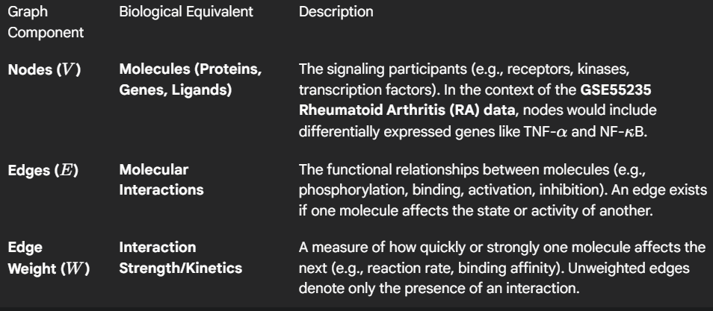

2. Graph Theory Metrics and Their Biological Interpretation (CO4)
Applying specific graph metrics allows for the functional understanding of a signaling pathway.
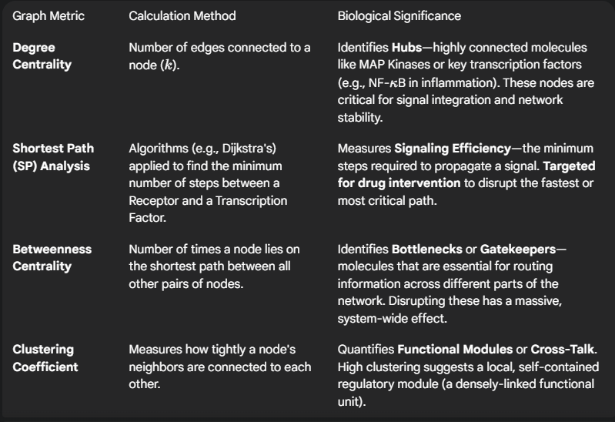
3. Understanding Cell Signaling Processes (BTL5: Evaluation/Synthesis)
Graph theory is not just descriptive; it is used to evaluate and predict cellular behavior.
A. Signal Propagation and Efficiency
By using Shortest Path analysis, we can determine the route and time a signal takes. When analyzing RA data (GSE55235), we can map the shortest path from an upregulated cytokine (e.g., Interleukin-6) to a downstream inflammatory transcription factor. A shorter path indicates a more rapid or direct immune response.
B. Robustness and Fragility
- Robustness: Networks often exhibit scale-free properties, meaning they tolerate random removal of most non-hub nodes. Graph theory helps confirm that even if one component fails, the signal can still reach its destination via alternative, slightly longer paths.
- Fragility: The high degree of central hub nodes makes the entire system fragile to targeted attacks (e.g., specific drug inhibition). If a hub with high Betweenness Centrality is removed, the network can fragment, effectively shutting down the signaling process.

C. Cross-Talk and Disease Mechanisms

Graph analysis readily identifies shared nodes or overlapping pathways, known as cross-talk.
- Application in RA: In inflammatory diseases, multiple signaling pathways (e.g., JAK-STAT, NF-B) often converge on common nodes. Graph analysis identifies these convergence points as the molecular mechanism responsible for integrating various inflammatory signals, providing a key insight into how the disease pathology is sustained.

5 - Presentation of Protein-Protein Network Analysis [CO3] [BTL2]

I. Introduction and Objective
This report outlines the standard procedures for presenting the results of a Protein-Protein Interaction (PPI) Network Analysis derived from gene expression data, such as the GSE55235 (Rheumatoid Arthritis vs. Healthy Controls) dataset. The objective is to effectively communicate the topological structure of the disease-specific network, identify key molecular players, and establish the biological relevance of the findings.

II. Presentation of Network Construction
The presentation begins by validating the data source and defining the resulting graph structure.
- Data Source Integration:
  - Clearly state the input data: Differentially Expressed Genes (DEGs) derived from the statistical analysis of the GSE55235 dataset (, ).
  - State the PPI database used (e.g., STRING, BioGRID) and the confidence score threshold applied (e.g., for STRING) to filter reliable edges.
- Network Visualization:
  - Display the final network using a visualization tool (e.g., Cytoscape).
  - Nodes (Proteins): Use color gradients to map Log Fold Change (LogFC) from GSE55235 (e.g., deep red for high upregulation in RA, dark blue for high downregulation). Node size can represent gene expression significance ().
  - Edges (Interactions): Edge thickness should represent the interaction confidence score.

III. Presentation of Topological Analysis Metrics (CO3, BTL2)
The quantitative results of graph theory analysis are presented to identify functionally important proteins.
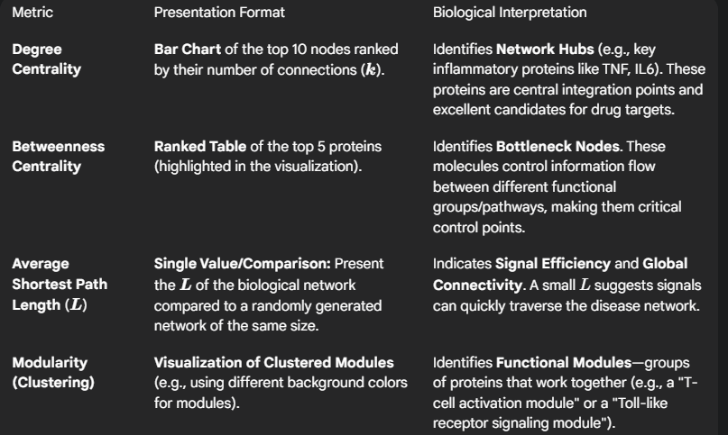

IV. Presentation of Functional Enrichment
This section bridges the abstract topological results back to the specific biology of Rheumatoid Arthritis.
- Pathway Enrichment Analysis:
  - Present a Bar Chart of the top 5 most significantly enriched KEGG or Reactome pathways associated with the network proteins.
  - Focus: The presentation should emphasize pathways directly linked to RA pathophysiology (e.g., NF-B signaling, Apoptosis, Cytokine-Cytokine Receptor Interaction).
- Linking Topology to Function:
  - Provide a figure or table showing how the identified Hubs (high degree) or Bottlenecks (high betweenness) belong to the most enriched inflammatory pathways. Example: "Protein X (Highest Degree) is a core component of the JAK-STAT pathway."

V. Conclusion and Target Nomination
The final part summarizes the findings and proposes validated targets.
- Summary: Concisely state the key findings (e.g., "The RA network exhibits high modularity and a short average path length, suggesting rapid and localized signaling.").
- Target Candidates: Based on the confluence of high topological significance (Hub/Bottleneck status) and high biological significance (membership in critical RA pathways), nominate 2-3 specific proteins as potential therapeutic targets for functional validation.
The objective is to synthesize the topological metrics and functional enrichment results into simple, actionable biological statements.
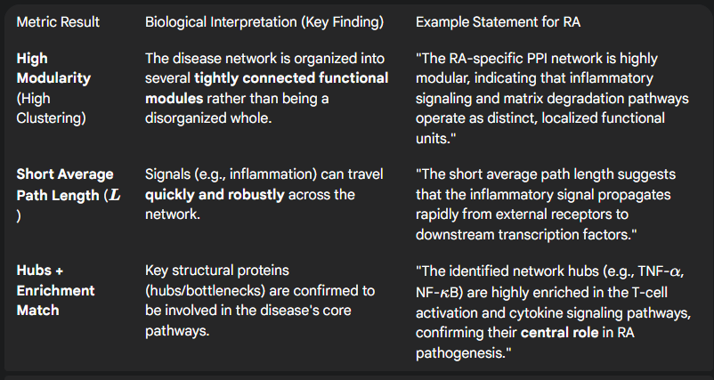

THE END

